**Lab 16: Android ActionBar**

# **Introduction**

**ActionBar** is the element present at the top of the [activity](https://www.geeksforgeeks.org/activity-lifecycle-in-android-with-demo-app/) screen. It is a prominent feature of a mobile applications having a consistent presence over all their activities. It provides a visual structure to the app and contains some of the frequently used elements for the users. Before the release of Android 3.0 in 2013 the ActionBar was called the AppBar which could not be customized by developers and users.

**Let’s get Started:**

**Step 1: Create a New Project in Android Studio as shown below**

**Step 2: Select Empty Activity as shown below**

**Step 3: Provide a Project Name as shown below**

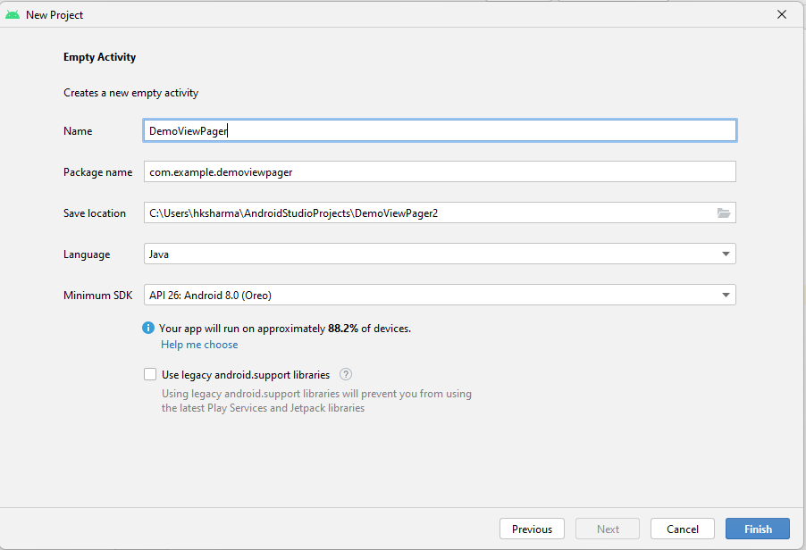

**Step 4: Update MainActivity.java as per the code given below**

**package** com.example.demoviewpager;  
  
**import** androidx.appcompat.app.AppCompatActivity;  
  
**import** android.os.Bundle;  
  
**public class** MainActivity **extends** AppCompatActivity {  
  
 @Override  
 **protected void** onCreate(Bundle savedInstanceState) {  
 **super**.onCreate(savedInstanceState);  
 setContentView(R.layout.***activity_main***);  
 }  
}

**Step 5: Update activity_main.xml for Vertical Orientation as per the code given below**

|  |
| --- |
| <?**xml** version="1.0" encoding="utf-8"?>  <**androidx.constraintlayout.widget.ConstraintLayout**      xmlns:android="<http://schemas.android.com/apk/res/android>"      xmlns:app="<http://schemas.android.com/apk/res-auto>"      xmlns:tools="<http://schemas.android.com/tools>"      android:layout_width="match_parent"      android:layout_height="match_parent"      android:background="#168BC34A"      tools:context=".MainActivity">        <!-- Adding a TextView in the activity -->      <**TextView**          android:layout_width="wrap_content"          android:layout_height="wrap_content"          android:text="Hello Geek!!"          android:textColor="#000000"          android:textSize="24sp"          android:textStyle="bold"          app:layout_constraintBottom_toBottomOf="parent"          app:layout_constraintLeft_toLeftOf="parent"          app:layout_constraintRight_toRightOf="parent"          app:layout_constraintTop_toTopOf="parent" />      </**androidx.constraintlayout.widget.ConstraintLayout**> |

**Step 6: Check Output on Android Emulator and it should look like as given below**

**Voila!!** We have successfully completed this lab.